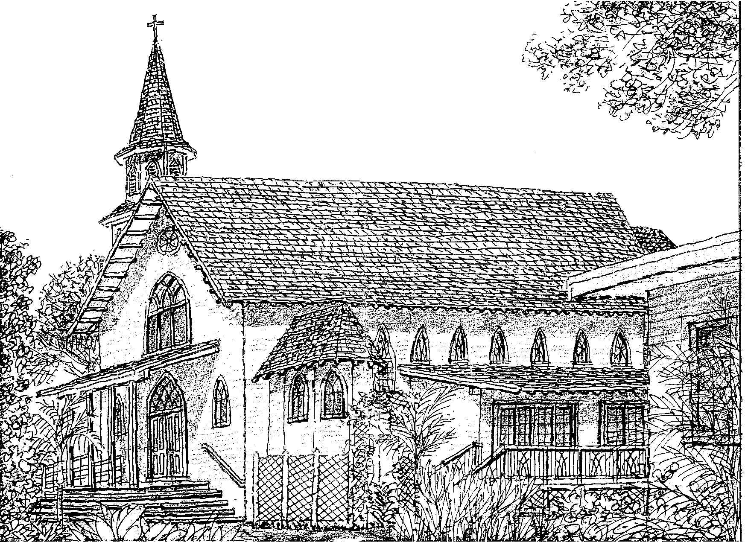

New

Updating registration

Immaculate Conception Church
91-1298 Renton Rd. Ewa Beach, HI 96706
Ph#: (808) 681-3701 Fax#: (808) 681-3117
Fr. Michel W. Dalton, O.F.M. Cap.

REGISTRATION FORM
For office use: Registered:

Sent letter:

FAMILY NAME: ID/ENV#:
(Office Use)

ADDRESS: City: HI Zip Code:

PHONE#: - - Other No.#: - - - -
Unlisted?

Optional Info: EMAIL:

 | Head of Household * | Spouse
Last Name
First Name
Birthdate | - - | - - | - - | - -
Sex: M or F
Marital Status *
Religion
Ethnicity
Language
spoken at home
Occupation
Disability (if any)
PLEASE USE THE BACK OF SHEET FOR MORE SPACE. IF WE CAN BE OF ANY ASSISTANCE, PLEASE DO NOT
HESITATE TO CALL US AT (808) 681-3701. Fax or Email to iccewa@rcchawaii.org or drop it off at the office. Mahalo!

I would like more information on becoming a Catholic.
I would like more information on your Religious Education program.
I would like more information on your different ministries within the parish.
Please call or email me at:
Notes:

9/19/2012

